Media Query

<!DOCTYPE html>

<html>

<head>

<meta name="viewport" content="width=device-width, initial-scale=1.0">

<style>

\* {

  box-sizing: border-box;

}

.row::after {

  content: "";

  clear: both;

  display: table;

}

[class\*="col-"] {

  float: left;

  padding: 15px;

}

html {

  font-family: "Lucida Sans", sans-serif;

}

.header {

  background-color: #9933cc;

  color: #ffffff;

  padding: 15px;

}

.menu ul {

  list-style-type: none;

  margin: 0;

  padding: 0;

}

.menu li {

  padding: 8px;

  margin-bottom: 7px;

  background-color: #33b5e5;

  color: #ffffff;

  box-shadow: 0 1px 3px rgba(0,0,0,0.12), 0 1px 2px rgba(0,0,0,0.24);

}

.menu li:hover {

  background-color: #0099cc;

}

.aside {

  background-color: #33b5e5;

  padding: 15px;

  color: #ffffff;

  text-align: center;

  font-size: 14px;

  box-shadow: 0 1px 3px rgba(0,0,0,0.12), 0 1px 2px rgba(0,0,0,0.24);

}

.footer {

  background-color: #0099cc;

  color: #ffffff;

  text-align: center;

  font-size: 12px;

  padding: 15px;

}

/\* For mobile phones: \*/

[class\*="col-"] {

  width: 100%;

}

@media only screen and (min-width: 768px) {

  /\* For desktop: \*/

  .col-1 {width: 8.33%;}

  .col-2 {width: 16.66%;}

  .col-3 {width: 25%;}

  .col-4 {width: 33.33%;}

  .col-5 {width: 41.66%;}

  .col-6 {width: 50%;}

  .col-7 {width: 58.33%;}

  .col-8 {width: 66.66%;}

  .col-9 {width: 75%;}

  .col-10 {width: 83.33%;}

  .col-11 {width: 91.66%;}

  .col-12 {width: 100%;}

}

</style>

</head>

<body>

<div class="header">

  <h1>Chania</h1>

</div>

<div class="row">

  <div class="col-3 menu">

    <ul>

      <li>The Flight</li>

      <li>The City</li>

      <li>The Island</li>

      <li>The Food</li>

    </ul>

  </div>

  <div class="col-6">

    <h1>The City</h1>

    <p>Chania is the capital of the Chania region on the island of Crete. The city can be divided in two parts, the old town and the modern city.</p>

  </div>

  <div class="col-3 right">

    <div class="aside">

      <h2>What?</h2>

      <p>Chania is a city on the island of Crete.</p>

      <h2>Where?</h2>

      <p>Crete is a Greek island in the Mediterranean Sea.</p>

      <h2>How?</h2>

      <p>You can reach Chania airport from all over Europe.</p>

    </div>

  </div>

</div>

<div class="footer">

  <p>Resize the browser window to see how the content respond to the resizing.</p>

</div>

</body>

</html>

For Desktop :

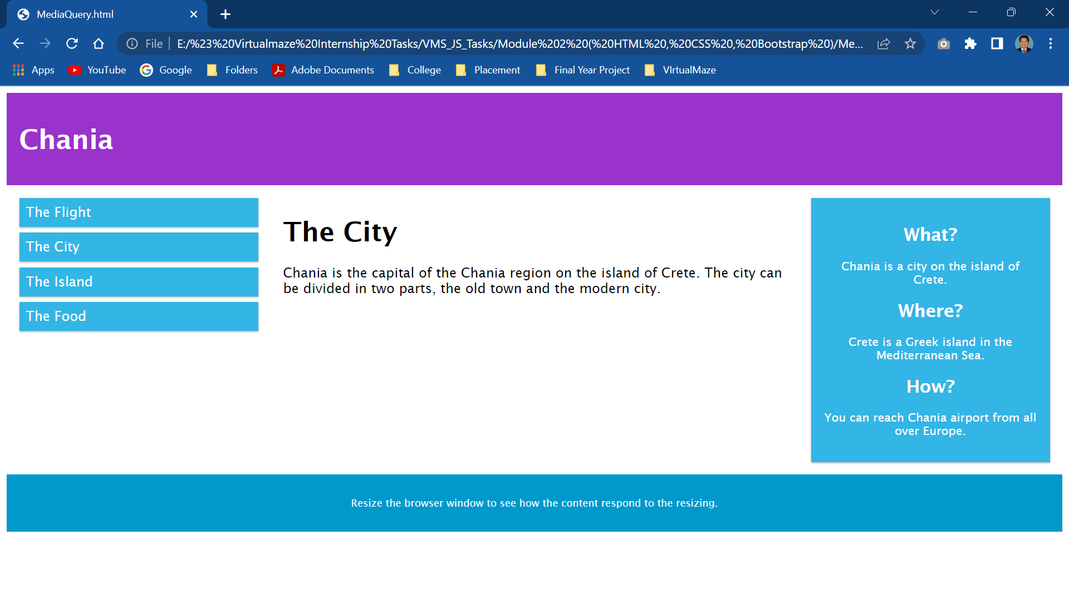

For Tablet :

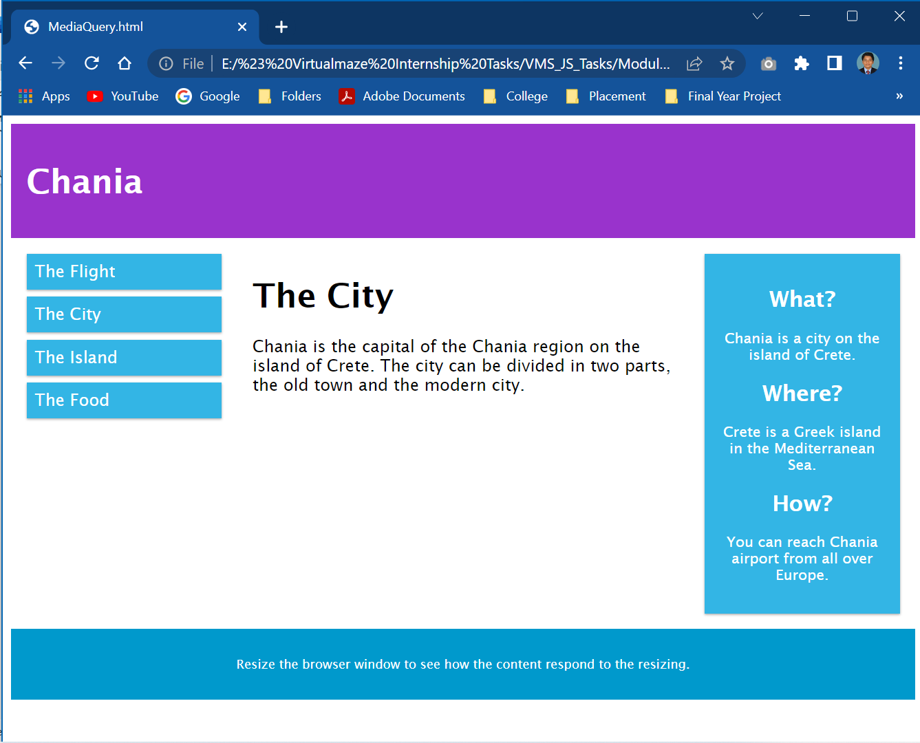

For Mobile :

